

**Cologne University of Applied Sciences**

**Master’s Program**

**Automation&IT and Informatik / Computer Science**

Project Documentation

Relational Databases

Prof. Dr. Damian Gawenda

Wintersemester 2020/21

Written by

Faaiz Ahmed

Matriculation Number: 11148258

City: Gummersbach (Germany) Date: 20 March 2021

Project: Online Shopping Store

-Inspired from Amazon, can be customized to accommodate any type of online retail.

**Use Cases:**

* Users are able to log in using their ID and password.
* There are multiple categories of items available on the store.
* The order can be placed by the user consisting of multiple products from different categories.
* The application is able to show the total orders.
* The information in the database is stored and can be viewed on a local host machine.

Entity Relationship Diagram:

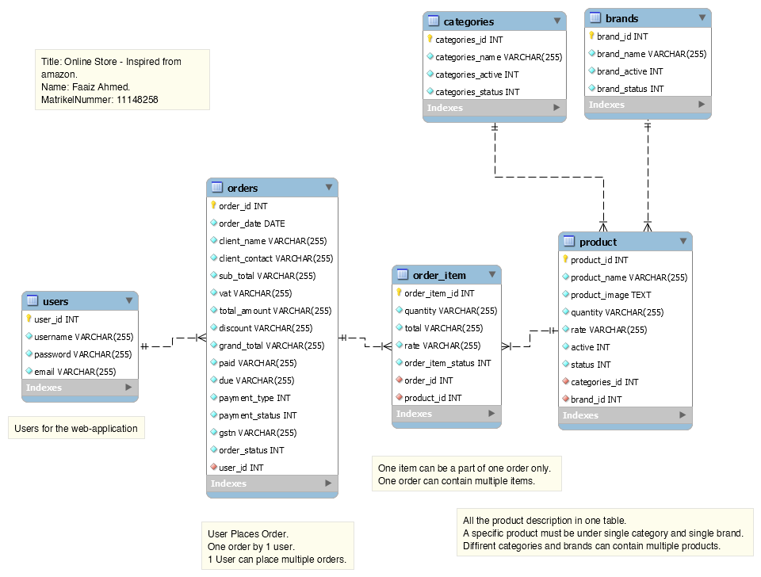

SQL Code:

/*

--- Relational Database project ---

--- Author: Faaiz Ahmed ---

--- Matrikel Nummer: 11148258 ---

--- Project: Online Store like Amazon ---

*/

# DDL- Data definition language

# CREATE,ALTER,DROP

# Droping Tables

DROP TABLE IF EXISTS brands;

DROP TABLE IF EXISTS categories;

DROP TABLE IF EXISTS orders;

DROP TABLE IF EXISTS order_item;

DROP TABLE IF EXISTS product;

DROP TABLE IF EXISTS users;

CREATE TABLE `users` (

`user_id` int(11) NOT NULL,

`username` varchar(255) NOT NULL,

`password` varchar(255) NOT NULL,

`email` varchar(255) NOT NULL

);

ALTER TABLE `users`

ADD PRIMARY KEY (`user_id`),

MODIFY `user_id` int(11) NOT NULL AUTO_INCREMENT;

CREATE TABLE `brands` (

`brand_id` int(11) NOT NULL,

`brand_name` varchar(255) NOT NULL,

`brand_active` int(11) NOT NULL DEFAULT 0,

`brand_status` int(11) NOT NULL DEFAULT 0

);

ALTER TABLE `brands`

ADD PRIMARY KEY (`brand_id`),

MODIFY `brand_id` int(11) NOT NULL AUTO_INCREMENT;

CREATE TABLE `categories` (

`categories_id` int(11) NOT NULL,

`categories_name` varchar(255) NOT NULL,

`categories_active` int(11) NOT NULL DEFAULT 0,

`categories_status` int(11) NOT NULL DEFAULT 0

);

ALTER TABLE `categories`

ADD PRIMARY KEY (`categories_id`),

MODIFY `categories_id` int(11) NOT NULL AUTO_INCREMENT;

CREATE TABLE `orders` (

`order_id` int(11) NOT NULL,

`order_date` date NOT NULL,

`client_name` varchar(255) NOT NULL,

`client_contact` varchar(255) NOT NULL,

`sub_total` varchar(255) NOT NULL,

`vat` varchar(255) NOT NULL,

`total_amount` varchar(255) NOT NULL,

`discount` varchar(255) NOT NULL,

`grand_total` varchar(255) NOT NULL,

`paid` varchar(255) NOT NULL,

`due` varchar(255) NOT NULL,

`payment_type` int(11) NOT NULL,

`payment_status` int(11) NOT NULL,

`payment_place` int(11) NOT NULL,

`gstn` varchar(255) NOT NULL,

`order_status` int(11) NOT NULL DEFAULT 0,

`user_id` int(11) NOT NULL,

CONSTRAINT `fk_user_id`

FOREIGN KEY (`user_id`)

REFERENCES `users` (`user_id`)

ON DELETE CASCADE

ON UPDATE CASCADE

);

ALTER TABLE `orders`

ADD PRIMARY KEY (`order_id`),

MODIFY `order_id` int(11) NOT NULL AUTO_INCREMENT;

CREATE TABLE `product` (

`product_id` int(11) NOT NULL,

`product_name` varchar(255) NOT NULL,

`product_image` text NOT NULL,

`brand_id` int(11) NOT NULL,

`categories_id` int(11) NOT NULL,

`quantity` varchar(255) NOT NULL,

`rate` varchar(255) NOT NULL,

`active` int(11) NOT NULL DEFAULT 0,

`status` int(11) NOT NULL DEFAULT 0,

CONSTRAINT `fk_product_brands1`

FOREIGN KEY (`brand_id`)

REFERENCES `store`.`brands` (`brand_id`)

ON DELETE NO ACTION

ON UPDATE NO ACTION,

CONSTRAINT `fk_product_categories1`

FOREIGN KEY (`categories_id`)

REFERENCES `store`.`categories` (`categories_id`)

ON DELETE NO ACTION

ON UPDATE NO ACTION

);

ALTER TABLE `product`

ADD PRIMARY KEY (`product_id`),

MODIFY `product_id` int(11) NOT NULL AUTO_INCREMENT;

CREATE TABLE `order_item` (

`order_item_id` int(11) NOT NULL,

`order_id` int(11) NOT NULL DEFAULT 0,

`product_id` int(11) NOT NULL DEFAULT 0,

`quantity` varchar(255) NOT NULL,

`rate` varchar(255) NOT NULL,

`total` varchar(255) NOT NULL,

`order_item_status` int(11) NOT NULL DEFAULT 0,

CONSTRAINT `fk_order_item_product1`

FOREIGN KEY (`product_id`)

REFERENCES `product` (`product_id`)

ON DELETE NO ACTION

ON UPDATE NO ACTION,

CONSTRAINT `fk_order_item_orders1`

FOREIGN KEY (`order_id`)

REFERENCES `orders` (`order_id`)

ON DELETE NO ACTION

ON UPDATE NO ACTION

);

ALTER TABLE `order_item`

ADD PRIMARY KEY (`order_item_id`),

MODIFY `order_item_id` int(11) NOT NULL AUTO_INCREMENT;

# DML- Data Manipulation language

# INSERT,UPDATE,DELETE

INSERT INTO `brands` (`brand_id`, `brand_name`, `brand_active`, `brand_status`) VALUES

(1, 'Samsung', 1, 1),

(2, 'Apple', 1, 1),

(3, 'Google', 1, 1),

(4, 'Huawei', 1, 1),

(5, 'LG', 2, 1),

(6, 'HP', 1, 1),

(7, 'Dell', 1, 1);

INSERT INTO `categories` (`categories_id`, `categories_name`, `categories_active`, `categories_status`) VALUES

(1, 'Mobiles', 1, 1),

(2, 'Laptops', 1, 1);

INSERT INTO `users` (`user_id`, `username`, `password`, `email`) VALUES

(1, 'admin', '21232f297a57a5a743894a0e4a801fc3', '');

INSERT INTO `orders` (`order_id`, `order_date`, `client_name`, `client_contact`, `sub_total`, `vat`, `total_amount`, `discount`, `grand_total`, `paid`, `due`, `payment_type`, `payment_status`, `payment_place`, `gstn`, `order_status`, `user_id`) VALUES

(1, '2021-03-22', 'Faaiz Ahmed', '012768465', '200.00', '36.00', '236.00', '0', '236.00', '0', '236.00', 2, 3, 2, '36.00', 1, 1),

INSERT INTO `product` (`product_id`, `product_name`, `product_image`, `brand_id`, `categories_id`, `quantity`, `rate`, `active`, `status`) VALUES

(1, 'Samsung Galaxy s10', '../assests/images/stock/17868608666044cd27cb3dd.jpg', 1, 1, '9', '200', 1, 1),

(2, 'iPhone 11', '../assests/images/stock/4838989776044d04567229.jpg', 2, 1, '15', '250', 1, 1),

(3, 'Huawei P30', '../assests/images/stock/16823540716044d20c9c192.jpg', 4, 1, '20', '150', 1, 1),

(4, 'Dell Latitude 5490', '../assests/images/stock/10218159986044d6df2486f.jpg', 7, 2, '9', '400', 1, 1);

INSERT INTO `order_item` (`order_item_id`, `order_id`, `product_id`, `quantity`, `rate`, `total`, `order_item_status`) VALUES

(1, 1, 1, '1', '200', '200.00', 1);